 | OKI Fantomi  Sitting Volleyball Team  Semira Frašte 11, 71000 Sarajevo  Fax: +387(0)33 450 450  Mobile: +387(0)61 789 822  oki.fantomi@gmail.com  http://www.fantomi.ba/ | 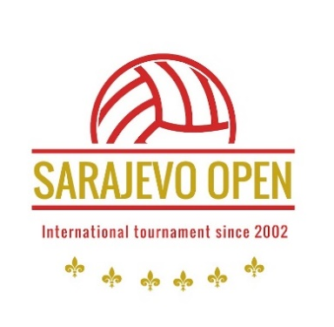

INVITATION

Dear Sport Friends,

Sitting Volleyball Team OKI Fantomi would like to invite your team to participate and be our guests in the International sitting volleyball tournament for men ''SARAJEVO OPEN 2024''. This is XXIII tournament that we organize. The tournament is scheduled from May 31th to June 02th 2024 in the Sport Hall ''Ramiz Salčin'' Mojmilo.

Please find attached the Registration form with relevant details for the tournament.

We sincerely hope that you will take participation in our tournament.

Best regards,

Sarajevo, December 2023

Ismet Godinjak
President
