 | OKI Fantomi  Sitting Volleyball Team  Semira Frašte 11, 71000 Sarajevo  Fax: +387(0)33 450 450  Mobile: +387(0)61 789 822  oki.fantomi@gmail.com  http://www.fantomi.ba/ | 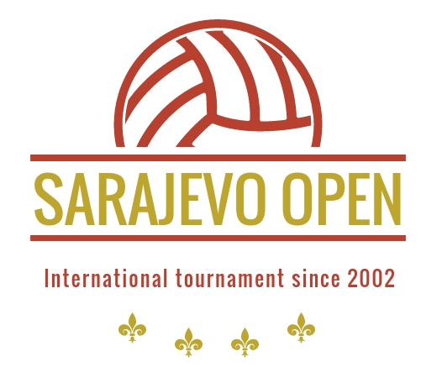

Dear sport friends,

The Club OKI Fantomi Sarajevo, Bosnia and Herzegovina, invites your club/team to participate in

XXI International Tournament in Sitting Volleyball for Men

''Sarajevo Open 2022''

Date: May 6th – May 8th 2022

Place: Sarajevo – Sport Hall ‘’Ramiz Salčin’’ Mojmilo

Food and accommodation in period from May 6th – May 8th 2022 in the Hotel ''ILIDŽA'' are GRATIS

Entry fee: € 500.-

Entry fee must be remitted before the beginning of the tournament.

Please mail your Registration form, containing your team personal info, to:

Name: Hana Delić
Address: Semira Fraste 11,
City: 71000 Sarajevo
Tel: ++387(0)33 450 450
Fax: ++387(0)33 450 450
Mobile: ++387(0) 62 104 069
E-Mail: oki.fantomi@gmail.com
Web-site: www.fantomi.ba

Deadline for submitting the Registration form is April 1st 2022.

Best regards,
Godinjak Ismet,
OKI Fantomi President

Registration Rules

XXI International Tournament in Sitting Volleyball for Men
Sarajevo Open 2022
May 6th – May 8th 2022 in Sarajevo

Please respect and adhere to the following rules:

- If up to April 1st 2022 the Registration form has not been received, tournament participation and accommodation will not be guaranteed.
- Entry fees received will not be refunded.
- Upon receipt of the Registration form and the entry fee you will be sent detailed information about the tournament schedule.
- We are entitled to make competition groups of the registered teams.
- All participating teams will receive receipt for entry fee paid.
- A recent team photograph is to be attached to the Registration Form.
Please send your Registration Form, duly filled in no later than April 1st 2022 to:
Name: Hana Delić
Address: Semira Frašte br.11
City: 71000 Sarajevo
Tel: +387(0)33 450 450
Fax: +387(0)33 450 450
Mobile: +387(0) 62 104 069
E-Mail: oki.fantomi@gmail.com
www.fantomi.ba

Note:
Maximum number of the participating team members is 15. In case your team will consist of more than 15 members, the Organiser will not cover food and accommodation costs for these additional members of your delegation. These costs are to be covered by participating teams, as well as all accommodation costs in case of longer staying in our city.

In case of earlier arrival and later departure of participating teams, costs of food and accommodation, transport and any training matches will be covered by participating teams. These costs are 50,00 Euros per person/day.

Sarajevo, December 22nd 2021

REGISTRATION FORM

(Club) Name | :
 | : | ____________________________________
Address | : | ____________________________________________________________________________________________________________
Phone | : | ____________________________________
Fax | : | ____________________________________
E-Mail | :

Date of arrival | : | ___________________
Time of arrival (approx.) | : | ___________________
Date of departure | : | ___________________
Time of departure | : | ___________________
Number of persons | : | _________

Accommodation in the hotel “Ilidža” (near the Sport Hall)
Costs: all costs for food and accommodation in period from Friday, May 6th (dinner) to Sunday, May 8^{h} 2022 (lunch) will be paid by the Organizer (OKI Fantomi)
Wheelchair users |  |  | : | __________
Remarks | :

