 | OKI Fantomi  Sitting Volleyball Team  Semira Frašte 11, 71000 Sarajevo  Fax: +387(0)33 450 450  Mobile: +387(0)61 550 484  oki.fantomi@gmail.com  http://www.fantomi.ba/ | 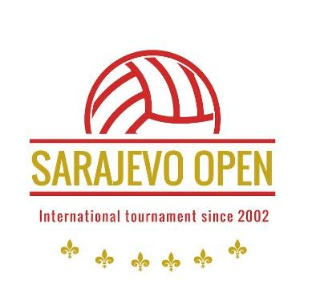

Dear sport friends, the Club OKI Fantomi Sarajevo, Bosnia and Herzegovina, invites your club/team to participate in

XXIII International Tournament in Sitting Volleyball for Men

''Sarajevo Open 2024''

Date: May 31st – June 2nd, 2024

Place: Sarajevo – Sports Hall ‘’Ramiz Salčin’’ Mojmilo

Food and accommodation in the period from May 31st – June 2nd, 2024 in the Hotel ''ILIDŽA'' are GRATIS

Entry fee: € 500.-

Entry fee must be remitted before the beginning of the tournament.

Please mail your Registration form, containing your team's personal info, to

Name: Mirzet Duran
Address: Semira Fraste 11,
City: 71000 Sarajevo
Fax: +387 33 450 450
Mobile: +387 61 550 484
E-Mail: oki.fantomi@gmail.com
Website: www.fantomi.ba

Deadline for submitting the Registration form is April 30th, 2024.

Best regards,
Godinjak Ismet,
OKI Fantomi President

Registration Rules

XXIII International Tournament in Sitting Volleyball for Men
Sarajevo Open 2024
May 31st – June 2nd 2024 in Sarajevo

Please respect and adhere to the following rules:

- If up to April 30th 2024 the Registration form has not been received, tournament participation and accommodation will not be guaranteed.
- Entry fees received will not be refunded.
- Upon receipt of the Registration form and the entry fee you will be sent detailed information about the tournament schedule.
- We are entitled to make competition groups of the registered teams.
- All participating teams will receive a receipt for the entry fee paid.
- A recent team photograph must be attached to the Registration Form.
Please send your Registration Form, duly filled in no later than April 30th 2024 to:
Name: Mizet Duran
Address: Semira Frašte br.11
City: 71000 Sarajevo
Fax: +387 33 450 450
Mobile: +387 61 550 484
E-Mail: oki.fantomi@gmail.com
Website: www.fantomi.ba

Note:
Maximum number of the participating team members is 15. In case your team will consist of more than 15 members, the Organiser will not cover food and accommodation costs for these additional members of your delegation. These costs are to be covered by participating teams, as well as all accommodation costs in case of longer staying in our city.

In case of earlier arrival and later departure of participating teams, costs of food and accommodation, transport and any training matches will be covered by participating teams. These costs are 50,00 Euros per person/day.

Sarajevo, December 2023

REGISTRATION FORM

(Club) Name | : | ________________________________________
 | : | ________________________________________
Address | : | ________________________________________________________________________________
Phone | : | ________________________________________
Fax | : | ________________________________________
E-Mail | :

Date of arrival | : | ___________________
Time of arrival (approx.) | : | ___________________
Date of departure | : | ___________________
Time of departure | : | ___________________
Number of persons | : | __________

Accommodation in the hotel “Ilidža” (near the Sport Hall)
Costs: all costs for food and accommodation in period from Friday, May 31st (dinner) to Sunday, June 2nd 2024 (lunch) will be paid by the Organizer (OKI Fantomi).
Wheelchair users |  |  | : | __________
Remarks | :

